08
Fall
GMU IT 357 Forensic Report
John Murray
This is an educational project for a George Mason University course. Contents of this report are part of a fictional scenario.
By submitting this assignment, I certify I have abided by all requirements of the GMU honor code. I certify that this is entirely my own work, no unauthorized sources have been used, and all sources used have been properly cited.

Investigator Information

My name is John Murray, and I am a computer forensic examiner working for the Federal Bureau of Investigation (FBI). I have around “12” years of forensic experience with the FBI.

Case Background

The Federal Bureau of Investigation (FBI) is investigating a series of threats that were posted on social media by James T. Buchs, who is a graduate student pursuing a Master of Arts in Political Science at George Mason University (GMU). Buchs has been residing in Beacon Hall at GMU’s Science and Technology campus in Manassas, Virginia, and he has been reported twice to GMU’s Violence Prevention Committee (VPC). After evaluation of his social media posts, the FBI determined that there was probable cause that indicates Buchs was a threat to the safety of the students and faculty at GMU. Thus, a search warrant was authorized for Buchs residence at 10945 George Mason Cir #212, Manassas, VA 20110. During the execution of the warrant, the FBI found a flash drive and was transported to the FBI forensic laboratory, where a forensic examiner produced a digital forensic image of the drive verified by hash values. This forensic image was then provided to me on 4/15/2025 for detailed forensic analysis.

Evidence Analyzed

The evidence I am analyzing and examining is a forensic image of a flash drive that was seized from James T. Buchs residence, created by the FBI forensic techs. The flash drive was found at Buchs’ apartment at 10945 George Mason Cir #212, Manassas, VA 20110. I obtained the verified forensic image file and associated hash values directly from the FBI lab for my detailed forensic analysis.

Verification of Evidence Integrity

To verify the evidence integrity, after downloading the image file I began to verify the hash from the suspect’s flash drive was matching the evidence image file received, for this process I utilized FTK Imager. On FTK imager, after adding the image file to FTK imager I right clicked on the IT-357-GMU-Buchs.E01 and used the verify drive/image selection to read the verified hashes. A hash is a cryptographic function like a mathematical algorithm that converts data into a fixed sized string of text that is unique which is the hash value and is important because it helps encrypt and decrypt digital signatures which verify the authenticity and integrity of a digital file. The MD5 hash was 2d91847bd8ec2370ba06710bd7ffd1a8, which was verified and confirmed to be the same.
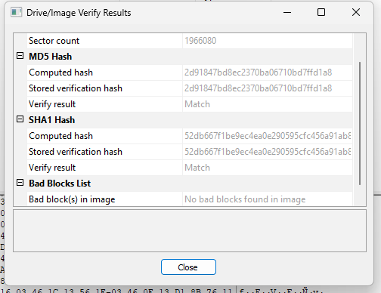

Forensic Tools

The forensic tools that I am using for this are Exterro FTK Imager 4.7.3.81 and Autopsy 4.21.0.

Overview

Before starting the forensic analysis, I validated all of my hardware and software tools to ensure proper functionality of my system and the applications. I then duplicated the forensic image provided by the FBI forensic techs and verified its authenticity using hash values. Once I confirmed the validity, I used Autopsy to extract and review the data, organizing the investigation by developing a list of directories and using it to guide the analysis. Any possible evidence pieces were marked as possible evidence (further focus needed). The drive structure included both automated and manual searches that I used to analyze the forensic image.

Documents

During the investigation of this forensic image, three documents were discovered in relation and lead investigation. The documents were found after opening the forensic image in the Autopsy application and verifying the hash value. After creating a new case in Autopsy, I then created a folder to store possible forensic data extracted. After adding the forensic image into the case, autopsy then processed the data and showed a structured view of the drive with recovered contents.

Security.docx

While going through the drives directories I found a document named “Security.docx”. This document was found in IT357-GMU-Buchs.E01_1 Host/IT357-GMU-Buchs.E01/Security.docx. The file was created on 2023-03-27 at 17:06:38 EDT and located in unallocated space (the area that hasn't been assigned to a partition, meaning it's not currently being used for data storage) with an internal ID of 221. The file was created using Microsoft Office Word. This file was deleted from the drive and that is known from the red “X” marked on the file. If the file was not deleted the file would not have a red “X” displayed on the file.

Appendix Item #1

Manifesto.docx

After finding the previous document, I then came across “Manifesto.docx”. The file was found in IT357-GMU-Buchs.E01_1 Host/IT357-GMU-Buchs.E01/Manifesto.docx and was deleted from the original drive as seen by the red “X” on the file.

Appendix Item #2

diaz, a - risk communication and the vt massacre.doc

This file was found at /img_IT357-GMU-Buchs.E01/diaz, a - risk communication and the vt massacre.doc and modified on 2024-01-10 at 09:23:48 EST. Talking about the importance of communication during crisis.

Appendix Item #3

Graphics

The process of finding the graphics is very similar to the documents section above. When going through the directories of the image I found 3 graphics to aid in investigation.

Images (1).jpg

I found this jpg image file when going through the directories, specifically in IT357-GMU-Buchs.E01_1 Host/IT357-GMU-Buchs.E01/images (1).jpg. This file was deleted from the original drive and can be seen by the red “X” displayed in the image file name. I recovered this image by extracting the image to my forensics file with forensic evidence inside.

Appendix item #4

22-060-Fairfax-Map.pdf

During investigation I came across a map file of Fairfax, created on 1980-01-01 at 00:00:00 EST and last accessed on 2024-01-10. The file was found in IT357-GMU-Buchs.E01_1 Host/IT357-GMU-Buchs.E01/22-060-Fairfax-Map.pdf and the file was not deleted however there was a deleted version that I did not include.

Appendix item #5

university-4-rt-er-231120_1700513176407_hpEmbed_3x2.jpg

Through investigation this image file was found that was created on 2024-01-10 with an internal ID of 444. The file was found in IT357-GMU-Buchs.E01_1 Host/IT357-GMU-Buchs.E01/university-4-rt-er-231120_1700513176407_hpEmbed_3x2.jpg, in allocated space. The file was not deleted and is proved by no red “X” in the file listing.

Appendix item #6

Deleted Files
During the investigation I found multiple deleted files in relation to the investigation. After opening the image in Autopsy and ensuring the verified hash value, I proceeded to the deleted files tab under the file views expanded section under the data sources in the left side of autopsy. This section of autopsy displays the deleted files that were recovered in the creation of the forensic image.

Links.docx

The first deleted file that I came across when investigating was found in the IT357-GMU-Buchs.E01_1 Host/IT357-GMU-Buchs.E01/Deleted Files/All/Links.docx and created on 2023-03-27 at 17:06:55 EDT. This file contains 5 links with bomb making awareness and response timeline in Michigan school shooting.

Appendix Item #7

_igure2.jpg

A deleted file created on 2023-03-27 with an internal ID of 233. The file was found in IT357-GMU-Buchs.E01_1 Host/IT357-GMU-Buchs.E01/Deleted Files/All/_igure2.jpg. The file contains an image of some kind of bullets.

Appendix item #8

_igure3.jpg

A deleted file created on 2023-03-27 with an internal ID of 187. The file was found in IT357-GMU-Buchs.E01_1 Host/IT357-GMU-Buchs.E01/Deleted Files/All/_igure3.jpg. The file contains an image of an assortment of weapons.

Appendix item #9

HTML or Web-based Files

The process and procedure of recovering HTML or Web-based Files is very similar to what is
described above on the documents and graphics.
remote detonator - Bombshock Forums.htm

This file is a linked file from visiting a forum on the topic of remote detonators created on 2023-03-27. The HTML was found in /img_IT357-GMU-Buchs.E01/remote detonator - Bombshock Forums.htm.

Appendix item #10

Bomb-Making Materials Awareness Program (BMAP) _ CISA.html

This file is a HTML file on Bomb making material awareness created on 2023-03-27. The HTML was found in /img_IT357-GMU-Buchs.E01/ Bomb-Making Materials Awareness Program (BMAP) _ CISA.html.

Appendix item #11

Beslan school siege_ Russia 'failed' in 2004 massacre - BBC News.html.
This file was found at /img_IT357-GMU-Buchs.E01/Beslan school siege_ Russia 'failed' in 2004 massacre - BBC News.html. This file contains news about a school siege in Russia that “failed”. It was created on 2023-07-27

Appendix item #12

OLE Subitems

In Autopsy, I began by creating a new case and loading the suspect's disk image to initiate the forensic investigation. I then navigated to the Data Artifacts section and selected Extracted Content, which could then reveal embedded files hidden within other files like emails or containers. These OLE Subitems are crucial because they often contain metadata, hidden content, or embedded evidence that can provide insight into document authorship and usage history in cybercrime cases.

university-2-rt-er-231120_1700512742812_hpEmbed_3x2.jpg

This file contains an embedded image of a photo with a sign saying, “Jews for Palestine”. This file was created on 2024-01-10 at 09:12:59 EST. It was found at /img_IT357-GMU-Buchs.E01/The Israel-Hamas war has college campuses on edge. How some are tackling the issue. - ABC News_files/university-2-rt-er-231120_1700512742812_hpEmbed_3x2.jpg.

Appendix item #13

Summary

A verified forensic image of a flash drive seized from the suspect’s residence that I obtained was analyzed using FTK Imager 4.7.3.81 and Autopsy 4.21.0. The drive contained deleted and recovered files, including documents (Security.docx, Manifesto.docx, diaz, a - risk communication and the vt massacre.doc), images (Images (1).jpg, _igure2.jpg, _igure3.jpg), and HTML files referencing bomb-making forums and awareness sites. The image also included a Fairfax map PDF and graphics potentially tied to university-related tensions. OLE Subitems in embedded HTML artifacts revealed additional visual content, such as politically charged imagery, further enhancing the evidentiary context. All recovered files were located through structured directory navigation, metadata timestamps, and deleted file listings within Autopsy, ensuring a factual and methodical examination.

Appendix

Appendix Item 1:

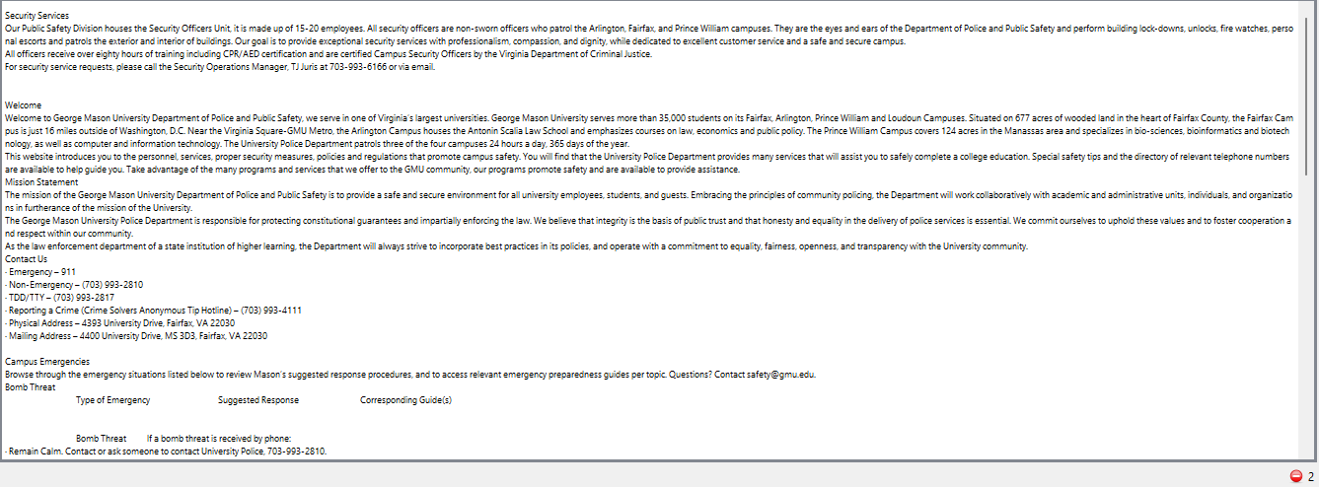

Appendix Item 2:

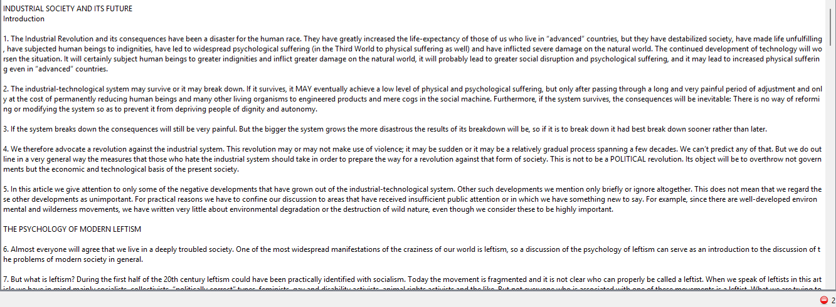

Appendix Item 3:

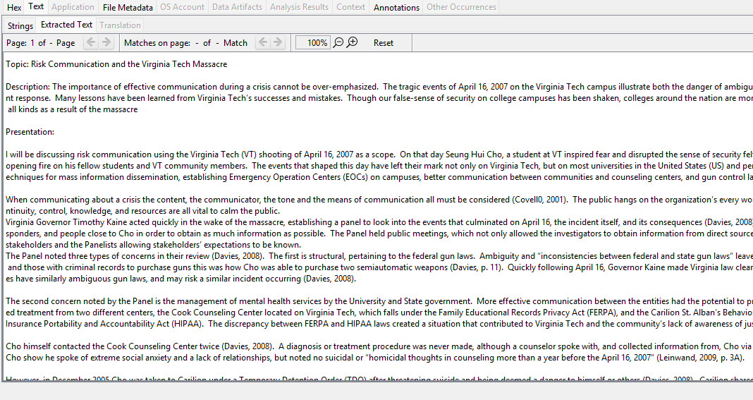

Appendix Item 4:

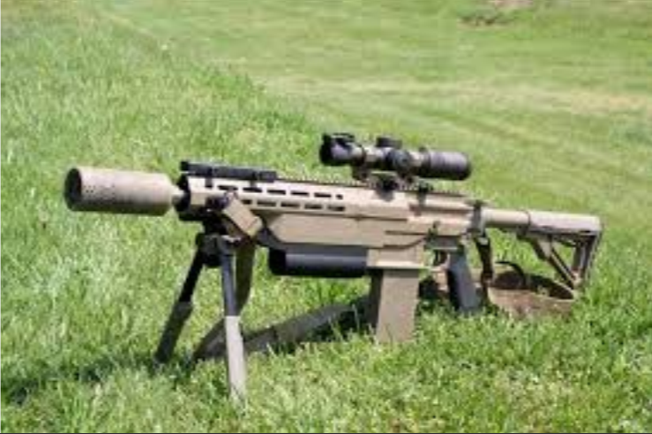

Appendix Item 5:

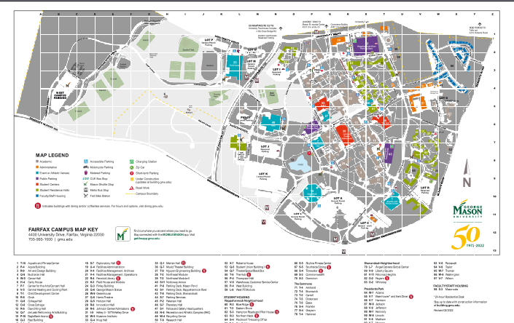

Appendix Item 6:

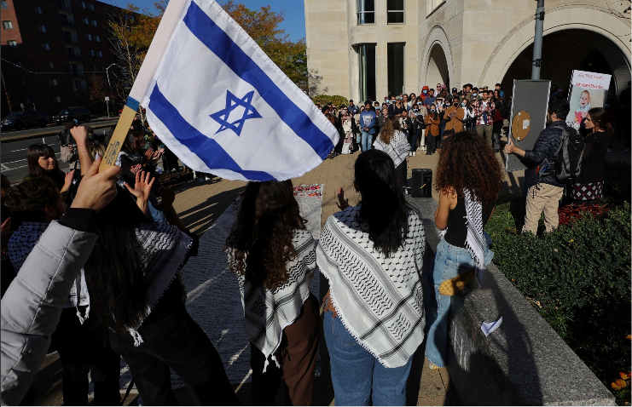

Appendix Item 7:

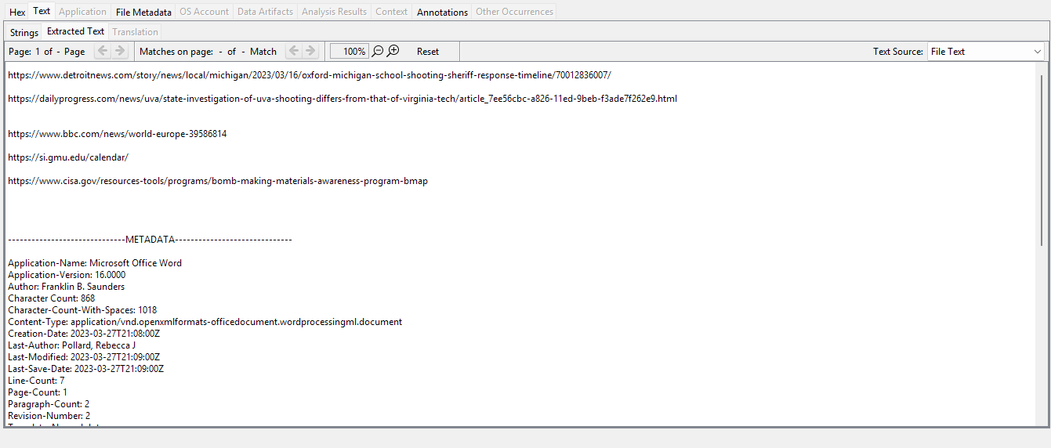

Appendix Item 8:

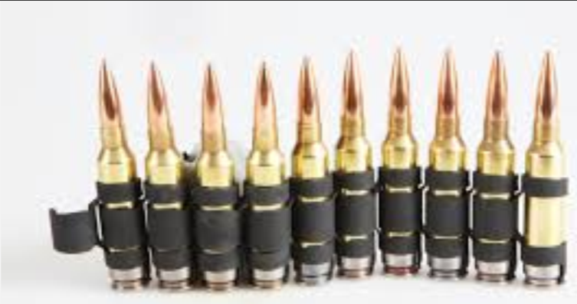

Appendix Item 9:

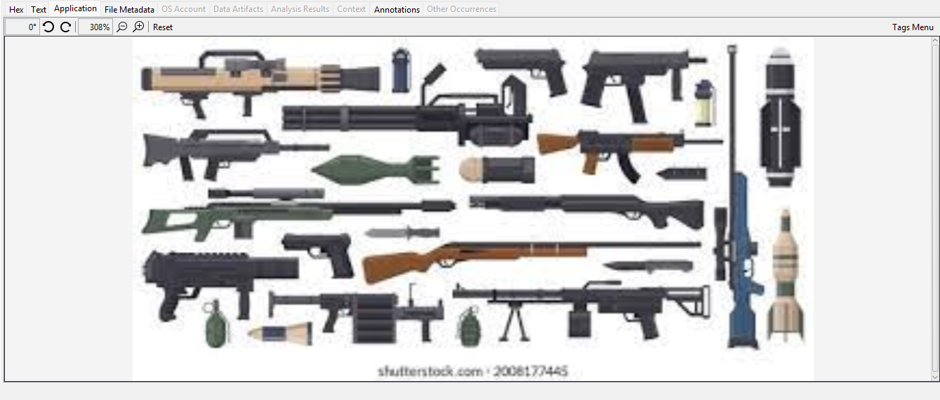

Appendix Item 10:

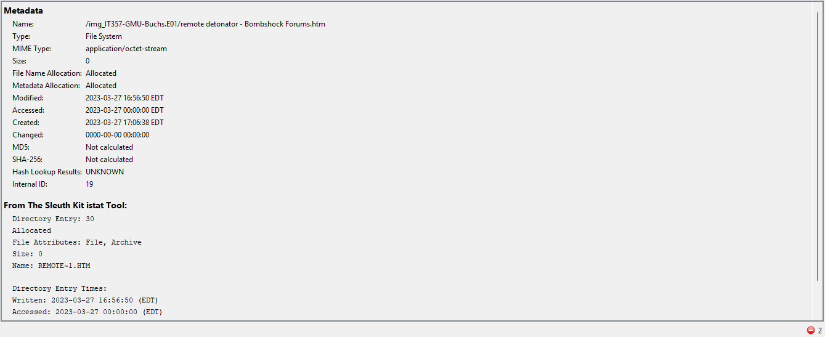

Appendix Item 11:

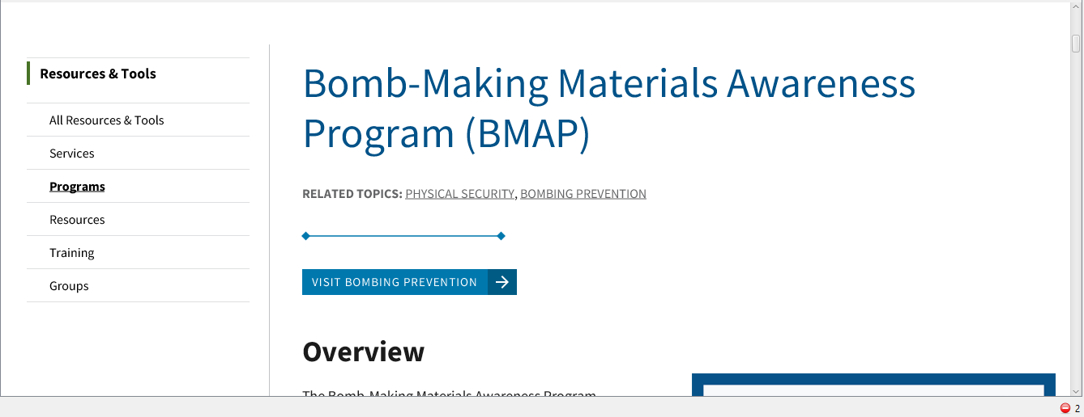

Appendix Item 12:

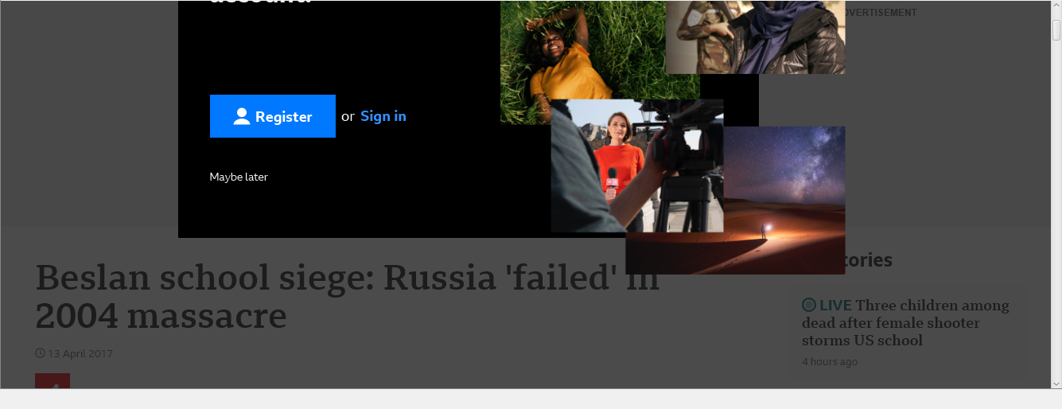

Appendix Item 13:

